Nuventive Solutions Premier – User Guide

Administrative Divisional/ Unit Plans and Results
Log in and Select your Unit
- Click on the link: https://solutions.nuventive.com/ and enter the Nuventive Solutions Premier platform using your CU SSO.
- Select your unit from the dropdown menu in the middle top of the screen

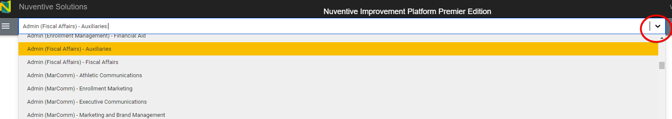

Enter/revise/discontinue Goals, Initiatives, Measures, and Targets
- Use the tabs on the left navigation bar to select Division / Unit Plans and Results

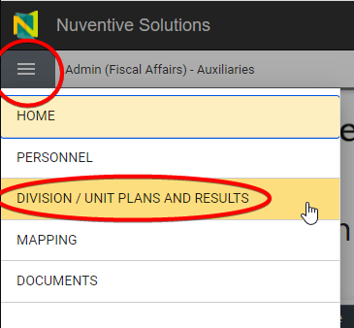

Add/revise/discontinue a goal/initiatives

Click on the green plus icon “+” on the far right of the header row to add a goal OR click three vertical dots to the far right of the GOAL NAME and open the goal you wish to edit/report results.

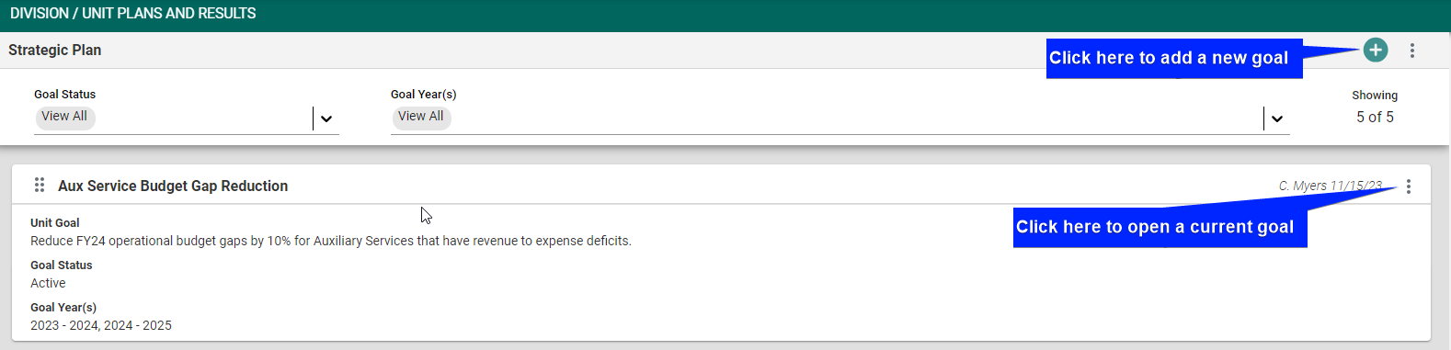

  - Click the UNIT GOAL TAB, add/revise the Goal name, Unit Goal, Goal Status, Goal Year(s), Initiatives, or other fields as needed.
  - Make a goal inactive, if needed, by selecting Goal Status and using the dropdown to choose complete, inactive, or on hold as appropriate
  - Add relevant Goal Year(s) for enduring goals that span multiple years
  - Label Initiatives with the appropriate year (e.g., 2023-24, 2024-25)
  - Click Save, the green button at the top of the screen, when finished and Close

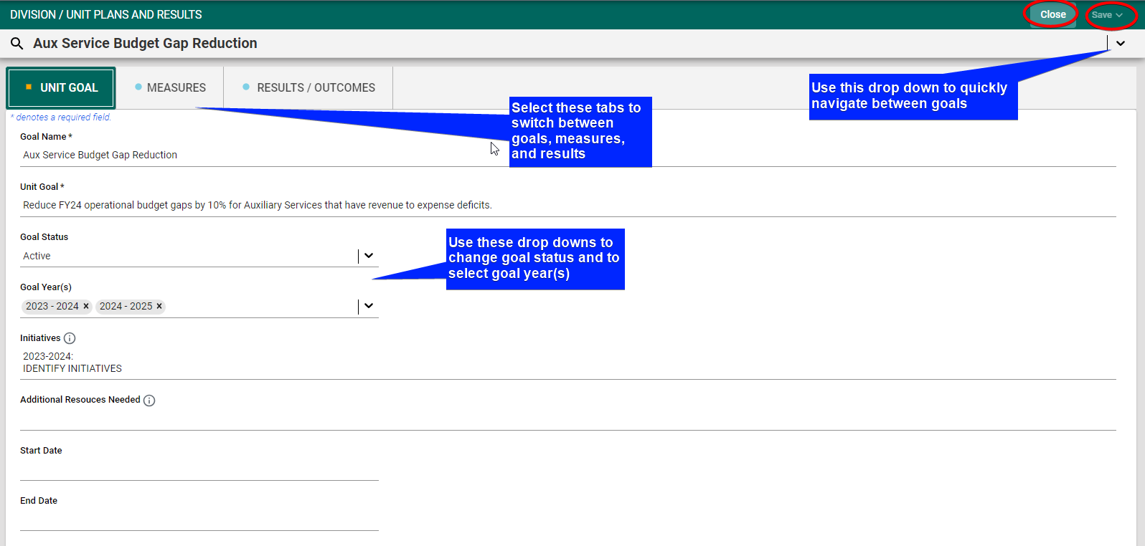

- Add/revise/discontinue measure/target
  - If revising or adding a new measure and/or target, click the MEASURES tab. Click on the green plus icon “+” on the far right of the header row to add a new measure or click on the three vertical dots to the far right of the goal name to edit measures/targets

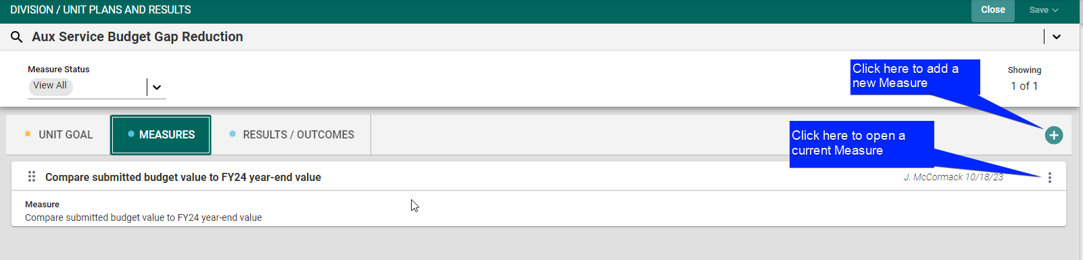

  - Add/revise the Measure Status, Measure, Target(s), or Notes. The target should be specific and measurable to identify the criteria for success of this particular goal (e.g., increase participation or completions by 5%)
  - Make a measure inactive, if needed, selecting Measure Status and using the dropdown to choose inactive as appropriate
  - Click on the green plus icon “+” under Related Documents to link supporting documentation (e.g., survey or assessment instrument, etc.)
  - Click Save, the green button at the top of the screen, when finished and Close

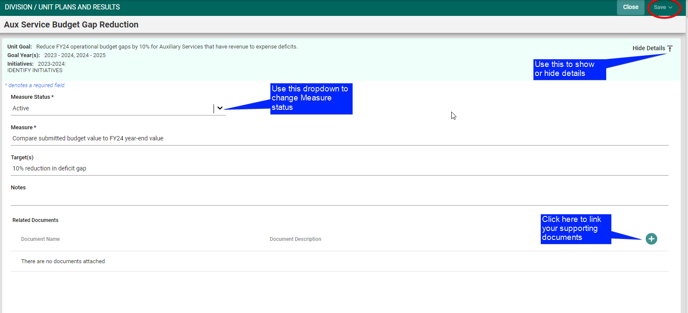

Add/revise results
    - Click the RESULTS/OUTCOMES tab. Click on the green plus icon “+” on the far right of the header row to add a new result/outcome or click on the three vertical dots to the far right to open/edit results/outcomes

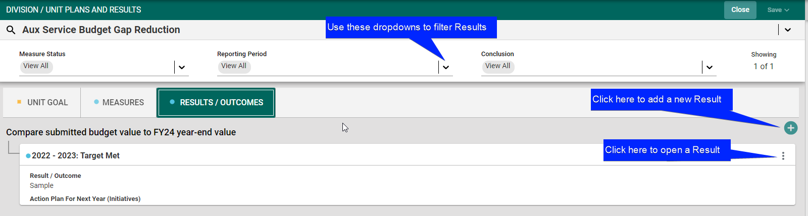

    - Edit/enter the Result/Outcome Date, Reporting Period, Result/Outcome (enter data and any explanatory narrative), Conclusion (Target met/target not met), and Action Plan for Next Year (be certain to enter high-level, data-driven actions based upon the results/outcomes)
    - Click on the green plus icon “+” under related documents to link supporting documentation (e.g., survey results, spreadsheets, etc.)
    - Click Save, the green button at the top of the screen, when finished and Close

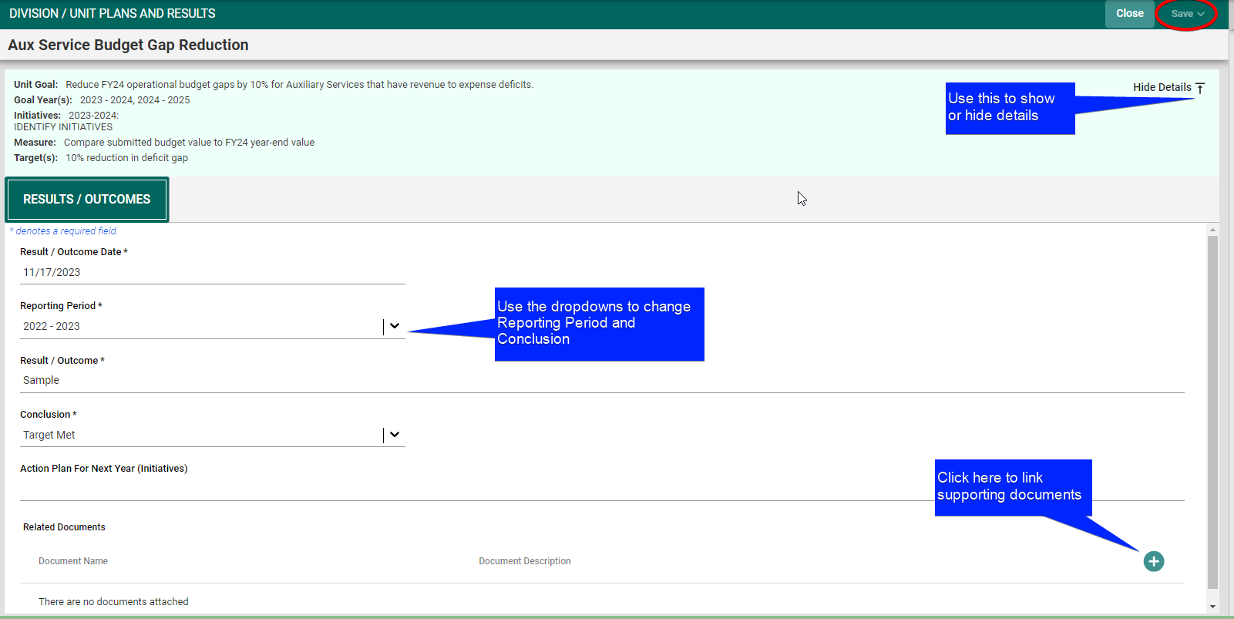

Mapping (click on “Mapping” on the left navigation bar)

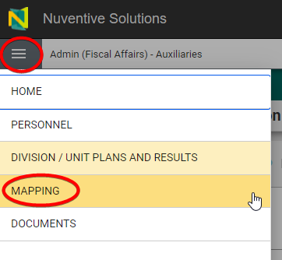

  - Click in each table cell where the Strategic Priorities and Core Commitments (in column) map to the Unit Goals (in header row)
  - Click Save, on the green bar at the top of the screen, when finished and Close

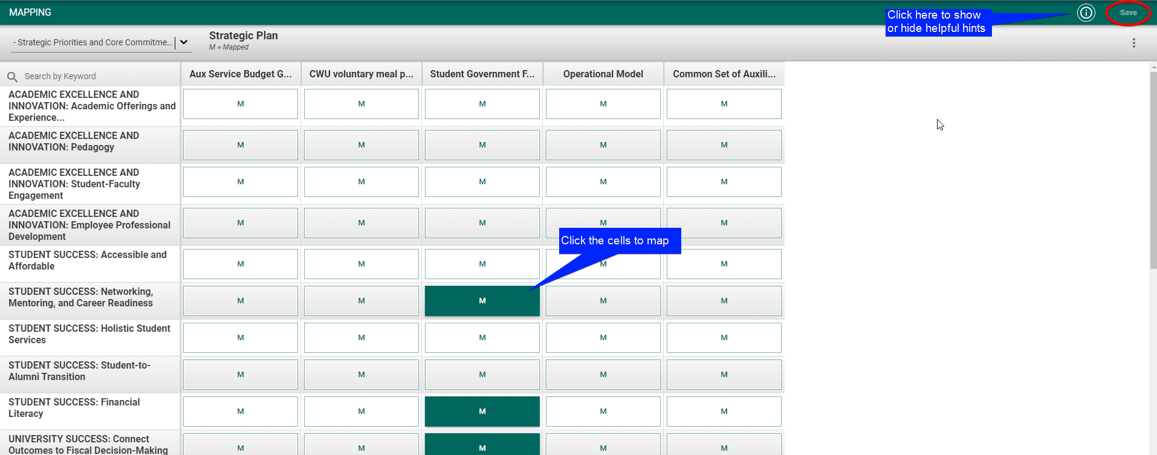

Reporting
- Use the tabs on the left navigation bar to select Home or Division / Unit Plans and Results

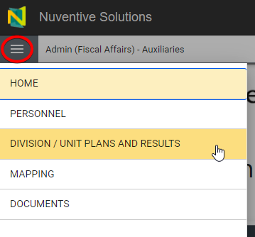

- Click on the Report Icon at the right side of the split screen

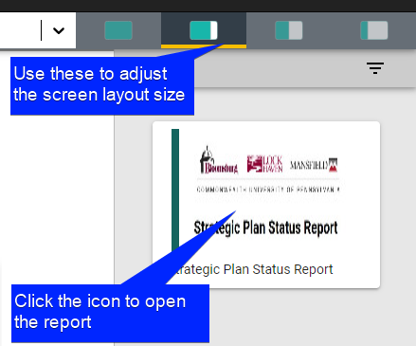

- Select appropriate Goal Status and Goal Year(s)/Reporting Period from the dropdowns
- Click the green Run Report button which should generate your report.

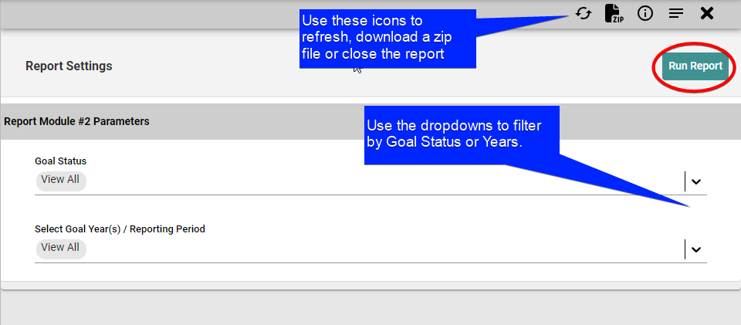

- Download the report if you wish.

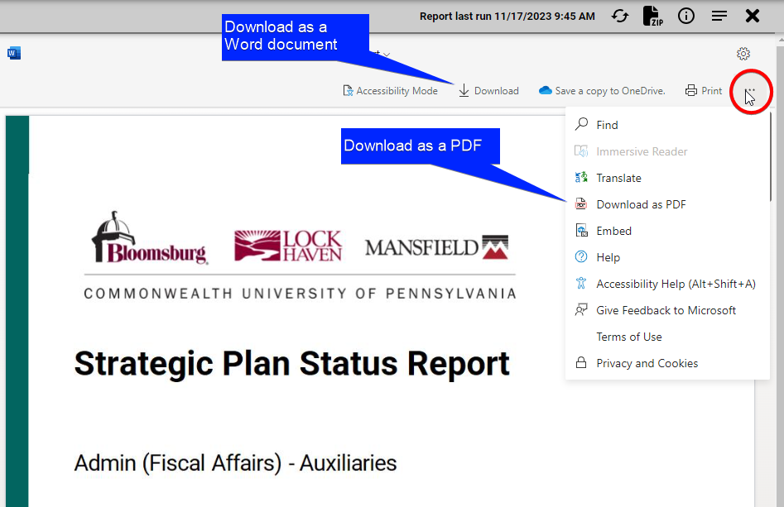

Documents (click on Documents on the left navigation bar)
- Select Document Repository from the left navigation bar

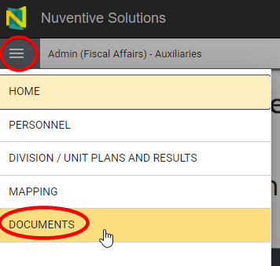

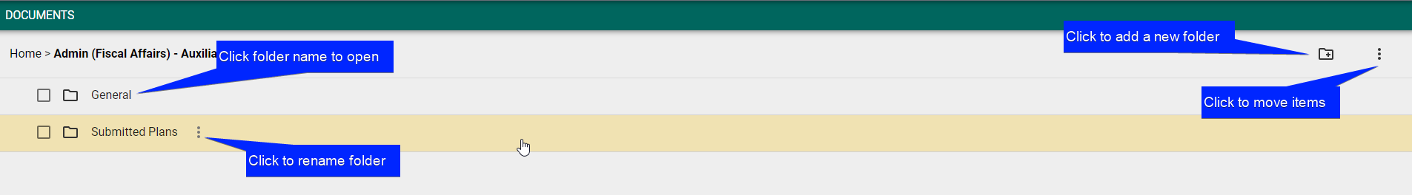

  - Click on the paper plus icon “+” on the far right to Upload New Document

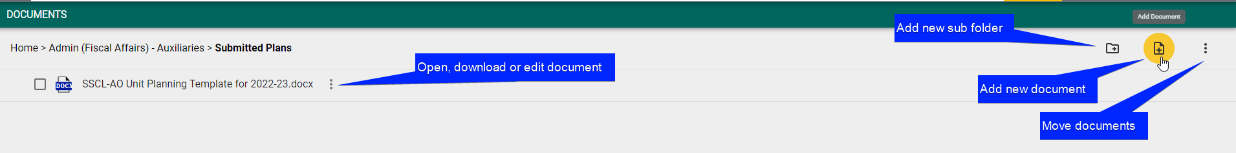

  - Browse, select file (supporting documentation), and click the green Save button

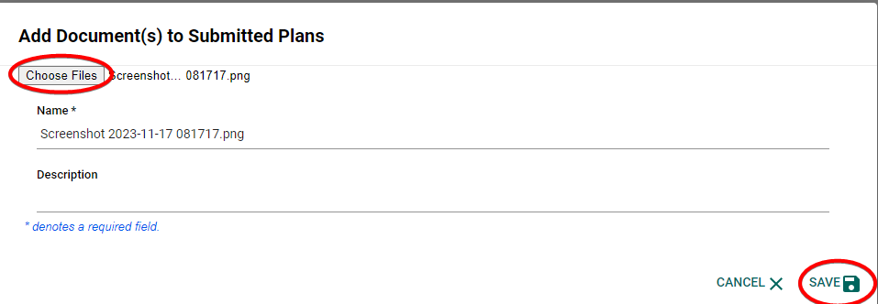

- Under the Division Unit Plans and Results area, you can link documents in the Measures and Results / Outcomes tabs
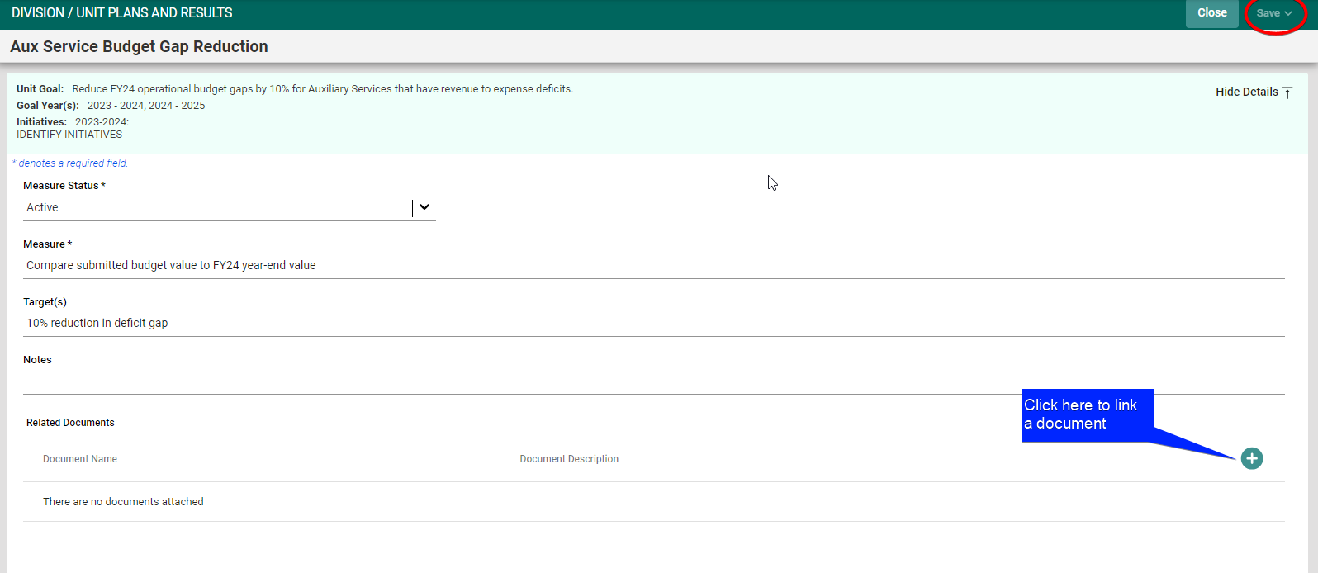

- Navigate to the document. Hit Attach in the upper right corner to relate the document
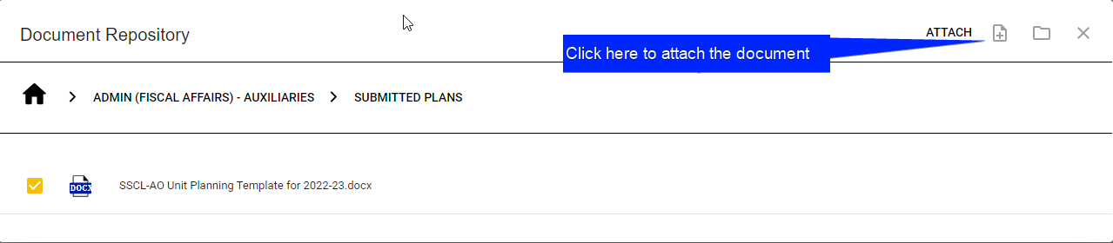

- Contact Shane Jones with questions about the organization of the Document Repository

